
Osborne’s Grays Triathlon - Sunday 13th July 2025 (incorporating Aquabike, Aquathlon)
Thank you for entering the Osborne’s Grays Triathlon. What follows is all the information you should need for the event. If you're a first timer, don't be daunted by the amount to remember, we'll go through it all with an online race briefing and the marshals will help send you in the right direction during the race.
Summary of Times
Registration: Your start numbers and timing chip will be in an envelope at Registration. Transition open from 06:15 Race briefing: Online.
Race starts 07:00
Last competitor finishes 10:00 (approx)
Address
Blackshots Leisure Centre, Blackshots Lane, Grays, Essex RM16 2JU Directions
From M25, leave at junction 30 (A13) East towards Tilbury. Go past the Lakeside turnoff then take next exit signposted Grays. At the roundabout take third turning signposted Orsett (Stifford Clays Road). Proceed for about half a mile then, as the road bends left, turn right into Blackshots Lane (if you go under the A13 you've missed the turning). Follow the road round a bend and past a mini roundabout; Blackshots Leisure Centre is about 400 yards past this junction on the left.
From Southend, take A13 to the Orsett Cock junction (A128, signpost Brentwood). At Roundabout take third exit (A1013) towards Grays. After approx 2 miles there is a roundabout, turn right (fourth exit); the Leisure Centre is on your right.
Car Parking
Address: There is free car parking at the venue, but please be advised that other users will also have access. I would recommend you arrive early and if possible, car share.
The Transition area will be open as soon as the last competitor is on the run course. Provisional results will be online during the day Sunday, with final results within 48 hours.

Registration
Your numbers and timing chip will be in an envelope to be collected from the Registration table. Your race number will be marked on both your upper arms at registration. If you are delayed on your journey, you can call ahead on 07525712324 and we will try to keep a place for you.
You will receive two race numbers that must be fixed to a number belt such that it is visible from behind on the bike and from the front on the run. If you have no number belt then fix it to your front and back. You will also receive stickers for your bike and helmet; ensure these are in place before you race. When leaving transition at the end of the race ensure your race number is visible as it will be checked to your bike number as a security measure. You will also receive a timing chip, please ensure this is fastened securely to your left ankle before you race and is returned at the end of the race.
Transition
Transition will be open from approx 6:15am. Only competitors and bikes will be allowed in and you must have your helmets fastened as you enter (helmets must be approved with an ANSI British Standard or SNELL sticker - NO HELMET, NO RACE).
Please ensure you don't impede any competitors who are racing when you are setting up or leaving your transition area. Please ensure you enter the transition area via the transition entry point and not over the timing mats (we will have marshals to help direct you). It is the responsibility of the competitors to ensure their bike is in a roadworthy condition, marshals will only check that bar end plugs are in place on the handlebars.
Briefing
This will be online. Any late urgent messages will be conveyed on the day in the safest manner possible.
Swim (400mtrs)
Please be at poolside 10 minutes before your start time (remember to wear your timing chip on your left ankle!) and be prepared to start earlier than your registered time. Upon entry to the Leisure Centre, follow directions to the pool. Wait by the deep end, until called forward. Each swimmer will be started at 30 second intervals starting at one side of the pool. Do two lengths in the first lane, keeping to the left at all times. At the end of the second length, back at the deep end, duck under the lane rope and do two further lengths in the second lane. Proceed like this until you have done 12 lengths (400 mtrs) and have reached the far side of the pool. Get out and exit through the emergency exit behind the training pool. Take care as the floor will be slippery – please do not run!

Note:
- if you need glasses or inhaler after your swim, please use the table provided at the side of the pool.
- You cannot wear calf guards or compression socks during the swim section of the race – if in any doubt please speak with the race official on the day.
Transition 1 (Swim to Bike, for aquathlon, Swim to Run)
Follow the signs to Swim Entry and into transition when you exit the pool. Ensure your helmet is on and fastened before removing your bike from the rack. Walk or run the bike out of transition. Also, don’t forget to have your race number either on a race belt or fastened to your t-shirt before you exit transition.
Aquathlon competitors will just put on their running gear and exit transition at the “Run Out” exit.
The mount line is approximately 30 metres from transition and you will be running over grass – so please bear this in mind when deciding to run in your feet or in your cycle shoes. The mount line will be clearly displayed and marshalled. Please do not mount your bike until both wheels have passed the mount line. When on your bike follow the signs and marshal directions through the car park to the exit of the Leisure Centre. At the exit from the car park there are traffic calming measures and there is a mandatory foot down area before you join Blackshots Road. This will be clearly marked and marshalled. Failure to stop and place your foot down will incur a time penalty. This is for your safety and a condition of the cycle permit as you will be joining on-coming traffic.
Bike Route (20k - 2 laps)
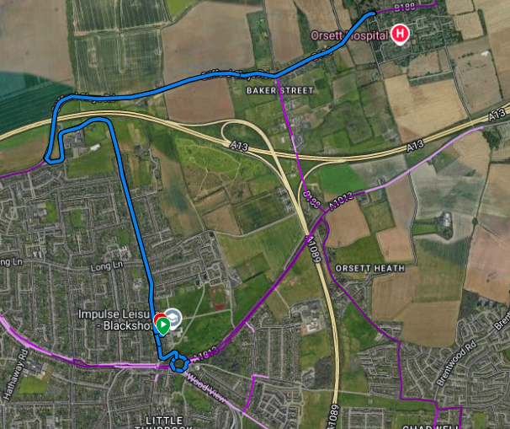
The bike course will be well signposted but not necessarily marshalled on every corner. Please be aware that it is the competitor’s responsibility to follow the correct course, so ensure you are familiar with the route before starting the race.
On exiting the Leisure Centre, you proceed to the large R/B, circle this R/B and return onto Blackshots Lane. Come back past the Leisure Centre on your right, and proceed to the mini R/B, carry on straight on Blackshots Lane. At the junction of Blackshots Lane and Stifford Clays Road there is right turn. THIS IS A COMPULSORY STOP AND FOOTDOWN, failure to comply will mean a disqualification. Follow Stifford Clays Road towards the village of Orsett, just before the village there is a mini R/B at the junction of Bonham Drive. Circumnavigate this mini R/B and return along Stifford Clays Road. Turn left back into Blackshots Road and at the mini R/B, carry straight on. The Leisure Centre will be on your left. Continue on Blackshots Road for your second lap.
At the end of the second lap, you will re-enter the leisure centre car park. Make your way back to the dismount line (which is in the same place as the mount line). Follow the marshal instructions who will help to direct traffic. Please take care when cycling in the car park as this may be heavily congested with cars for other users of the Leisure Centre. REMEMBER, YOU MUST COMPLETE TWO LAPS.
This is a non-drafting race; drafting rules for a race of this distance are thus:-
The bicycle draft zone will be 10 metres long measured from the leading edge of the front wheel. A competitor may enter the draft zone of another competitor, but must be seen to be progressing through that zone. A maximum of 20 seconds will be allowed to pass through the zone of another competitor; once overtaken a competitor must drop back outside of the drafting zone. Consecutive failed attempts to pass a competitor in front of you, is considered a drafting infringement and can be reported to the race official.
Transition 2 (Bike to Run, Bike to Finish for Aquabike)
When you return to Blackshots Leisure Centre please follow the directional arrows back to Transition. Please ensure you dismount your bike before any wheel crosses the dismount line, which will be marshalled, and sign posted and there will be a clearly visible line on the ground. You will run across a small section of grass before entering transition. Rack your bike before removing your helmet, then onto the run route for the first of three anti-clockwise laps, please ensure you drink enough on the bike course or whilst transitioning between the bike and run.
Aquabike competitors should rack their bike, remove their helmet, proceed through the “Run Out” exit and immediately move left through the finish line where your time will be taken.
Run (5km - 3 laps)

The course will be marked by tape; stay to the edge of the field at all times. At the end of the first and second lap stay left of the finish to start the third lap. At the end of the third lap turn go through the finish which is located just past transition.

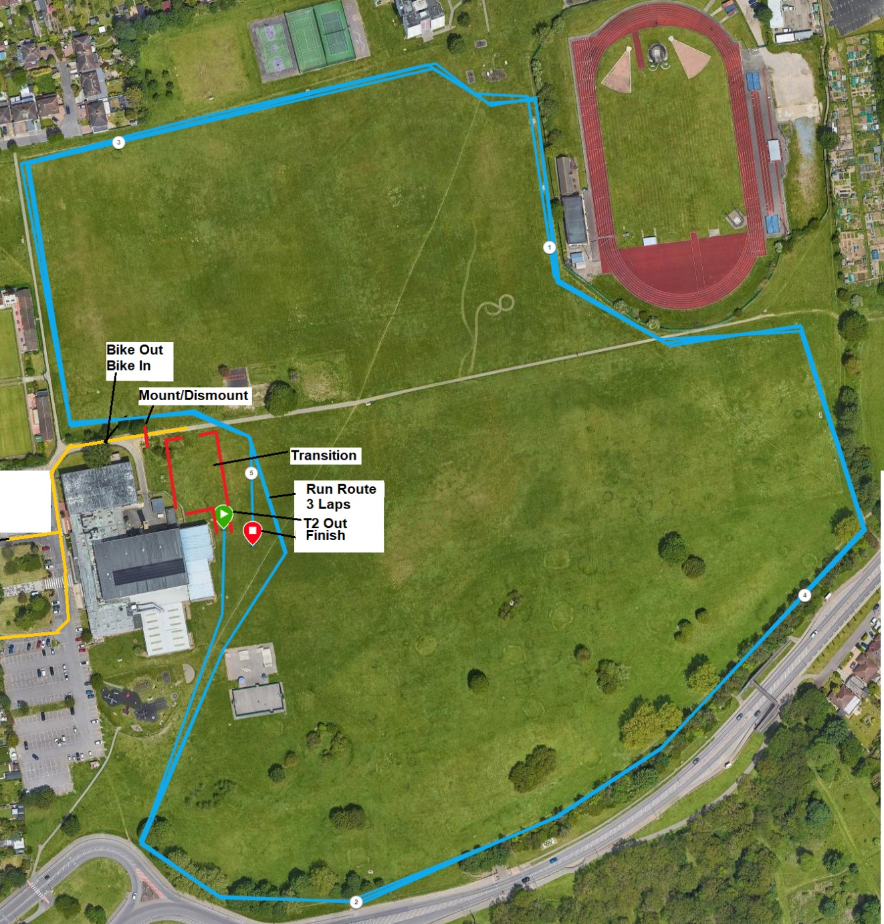

Race results
These will be posted online.
https://east-essex-tri-club.co.uk/uploads/documents/LiveResults.htm

Marshals
We would like to offer many thanks to the marshals who have volunteered (or have been volunteered) to give up their Sunday morning to allow the race to proceed. We hope they enjoy the race and will volunteer again in the future. Please treat them with respect at all times, any foul or abusive language towards them could lead to disqualification.
The Rules
The event is run in accordance with the rules of the British Triathlon Federation which are available on their website at www.britishtriathlon.org. The most common rules competitors tend to fall foul of are:
Bike Drafting (described above)
Marking your transition area (commonly with talc). The referee will remove this marking or, if the marking is permanent, will penalise the competitor. Touching the bike without having the helmet fastened; both in transition 1 and transition 2.
Folding your race number; they must not be cut or folded at any time
Cycling in transition; this means before the mount line or after the dismount line.
“Scooting” is also not allowed.
Nudity in transition (although not that common, it is a DQ offence)
Using MP3 players or other device while on the run or cycle
Thanks to:
Blackshots Leisure Centre - For use of the pool and complex.
Thurrock Council - for permitting use of the car park and run route.
Essex Police - for assisting with the bike route sanctioning
All Marshals - Club members, friends and relatives
Osborne’s, our Race Sponsors
The race team wish you all the best and hope you enjoy the day.

